

**Instituto Politécnico Nacional**

**ESCOM “Escuela Superior de Cómputo”**

INGENIERÍA EN SISTEMAS COMPUTACIONALES

*Análisis Fundamental de Circuitos*

*Práctica 6: Análisis de Nodos*

Profesor: Figueroa Del Prado Felipe De Jesus

ALUMNO:

Rojas Alvarado Luis Enrique

1CM6

Index

**Objective** **1**

**Material 1**

**Equipment 1**

**Theoric Introduction 1**

**Experimental progress 2**

**Calculations 2**

**Circuit simulations 3**

**Comparative of calculated, measured and simulated values 3**

**Questionary 6**

**Inferences 7**

**Bibliography 7**

# Objective

The student will apply the method of nodes to determine the voltages present in an electrical circuit, so that at the end of the practice, he will be able to use this technique in the calculation of the voltage drops present in networks containing multiple nodes.

# Material

* Breadboard
* 2 resistors (680 Ω)
* 2 resistors (330 Ω)
* 1 resistor (270 Ω)
* 1 resistor (560 Ω)
* 1 resistor (100 Ω)
* 2 resistors (1000 Ω)
* 4 points banana-banana
* 4 points banana-caiman

# Equipment

* Digital multimeter
* Variable voltage source

# Theoric introduction

The Law of Kirchhoff Currents, one of the main laws of electricity used in the analysis of electrical and electronic circuits. In this post I am going to explain to you how currents and voltages are in a circuit doing nodal analysis with Kirchhoff's Law of Currents. The first thing that is needed for this analysis is to know what a node is: In an electrical circuit, a node is a point where two or more elements of circuits cross, be it a source of voltage or current, resistors, capacitors, inductors, etc. The voltage method in the nodes is an organized method to analyze a circuit, which is based on the Kirchhoff law of the current.

What is the challenge of circuit analysis? Solving any circuit means creating and solving 2E2E2, E independent equations, where EEE is the number of elements (components and sources). Half of the equations come from the individual laws of the elements (like Ohm's law) and the other half comes from the connections between the elements.

Regardless of which procedure we use to solve the circuit, there is no way to reverse the requirement to solve 2E2E2, E equations. Even for simple circuits, handling 2E2E2, E equations can be a lot of work. But there are ways to organize the effort to make it very efficient. The voltage method in the nodes is one of two efficient procedures we have to solve circuits (the other is the mesh current method).

The voltage method in the nodes is not new science. It processes the same amount of information contained in 2E2E2, but organizes it very intelligently and efficiently.

# Experimental Progress

With the respective materials of the practice began by assembling the circuit in a breadboard, after this it was supplied with a voltage of 12 volts parallel to the nodes I and 0. Then with the help of a voltmeter and ammeter it began to measure (in the case of voltmeter) the voltages that circulated through each resistance of the circuit and (in the case of the ammeter) the currents through the four nodes measuring 2 in 2 and each given value was reflected in a table of values.

# Calculations

*(V3 - V2)/100 + (V1-V2) = (V2 –V1)/1000 + (V2 – V3)/680*

*(V1 - V2)/330 - V2/100 = (680V2 – 680V1 + 1000V2)/680000*

*(100V1 – 100V2 - 330V2)/33000 = (1680V2 – 680V1)/680000*

*(100V1 – 430V2)/33000 = 21V2/8300 - V1/1000*

*V1/330 - 43V2/3300 = 21V2/8300 - V1/1000*

Solving the system

# Circuit simulations

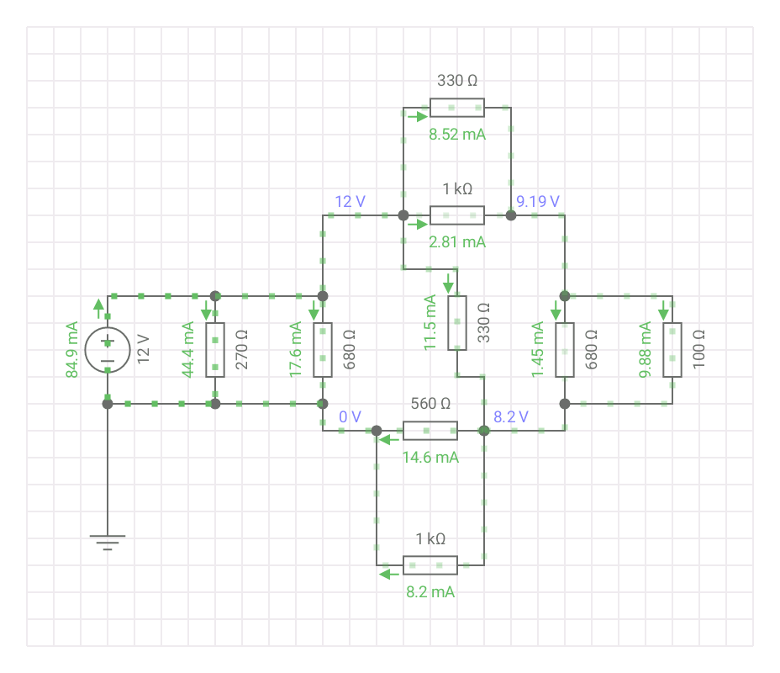

# Comparative of calculated, measured and simulated values

|  |  |  |  |
| --- | --- | --- | --- |
| Measurements | Theoric value | Simulated value | Measured value |
| Current 1 - 2 | 11.3 mA | 11.333 mA | 11.29 mA |
| Current 2 - 3 | 11.3 mA | 11.333 mA | 11.31 mA |
| Current 1 - 0 | 62.2 mA | 62.212 mA | 61.95 mA |
| Current 3 - 0 | 22.9 mA | 22.923 mA | 22.3 mA |

|  |  |  |  |
| --- | --- | --- | --- |
| Measurements | Theoric value | Simulated value | Measured value |
| Voltage 1 – 0 | 12 V | 12 V | 11.81 V |
| Voltage 2 – 0 | 9.1 V | 9.19 V | 10.5 V |
| Voltage 3 – 0 | 8.2 V | 8.2 V | 10.11 V |
| Voltage 1 – 2 | 2.8 V | 2.81 V | 1.27 V |
| Voltage 2 – 3 | 1 V | 0.99 V | 0.5 V |

|  |  |
| --- | --- |
| Resistors | Power |
| R1 | 12 mW |
| R2 | 3.95 mW |
| R3 | 0.27 mW |
| R4 | 106 mW |
| R5 | 21.9 mW |
| R6 | 0.22 mW |
| R7 | 4.88 mW |
| R8 | 60 mW |
| R9 | 33.6 mW |

# Questionary

1. Define that it is a node in an electrical circuit.
   1. A point in the circuit in which 2 or more elements are detached from it.
2. Define what the node voltage is.
   1. The voltage at which 2 different voltages pass
3. What is called the reference node?
   1. To the node that has the earth connected and has elements attached to it
4. Describe briefly what the node method consists of.
   1. Calculate voltages using the resistances and the addition and subtraction of the voltages that pass through it using Kirchhoff's laws.
5. Define what electric power is.
   1. The electrical power is the proportion per unit time, or rhythm, with which electrical energy is transferred by an electrical circuit.

# Inferences

Depending on how the resistors are connected and doing a bit of reduction in the circuit, it can give a clearer idea of what is going on theoretically at the moment of taking the values of the voltages and currents, but in the physical circuit it is not very appreciated Well this, since you have to measure according to what you have chosen as a reference.

# Bibliography

* <https://es.khanacademy.org/science/electrical-engineering/ee-circuit-analysis-topic/ee-dc-circuit-analysis/a/ee-node-voltage-method>
* <https://analisisdecircuitos1.wordpress.com/parte-1-circuitos-resistivos-cap-11-a-20-en-construccion/capitulo-20-analisis-de-nodos/>